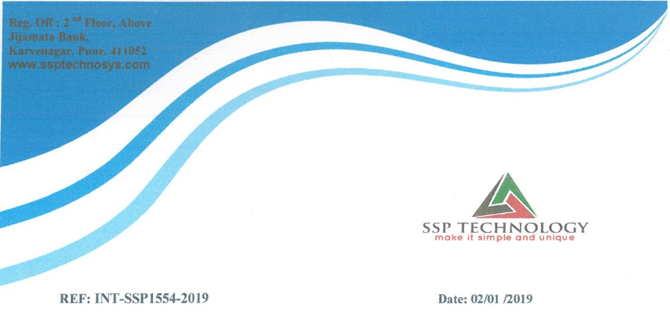

Dear Mr. Omkar Arun Surve,

This letter is with references to your internship application for the post of

“Java Developer Intern” We are happy to inform you that you have been

selected for the applied post and are offering internship position which will

be for a minimum period of Six Month. After further review of your

performance, you will be given a probation period

